Wangaratta Planning Scheme

18 Byrne Street, Moyhu (The Old Bank) Statement of Significance

Heritage Place: | 18 Byrne Street, Moyhu (The Old Bank) | PS ref no: | HO317

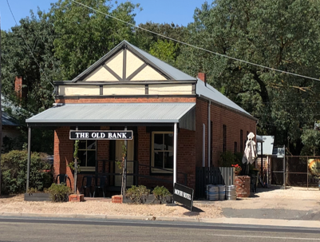
Image: Former Bank of Victoria

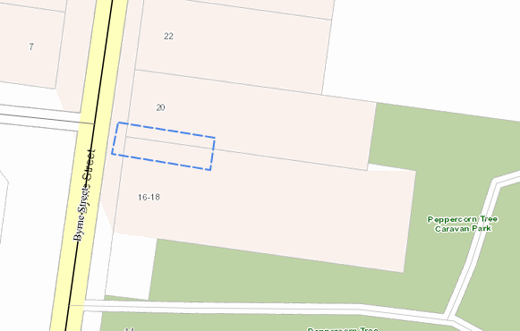
Location: 18 Byrne Street

What is significant?
18 Byrne Street Moyhu is significant.
Significant fabric includes, but is not confined to:
- Original form, fabric and scale of the commercial building;
- All of the architectural features found at the commercial building including the: gable roof clad with corrugated roofing; timber posted skillion roofed verandah; brick chimney; red face brick walling; gable shop front that includes a pressed metal cladding with timber strapping to upper section with a parapet type feature at the base of the gable; symmetrical façade with central timber door flanked on either side by four pane double hung timber sash windows and typical timber joinery.
- Side elevations and the original openings that include windows and doorway.
The building is substantially intact, and it has largely retained its original form.
Elements which are not considered significant are:
- Alterations from the mid twentieth century and later are not significant.
External paint and solar system controls apply. No internal alteration controls apply.
How is it significant?
18 Byrne Street Moyhu is of local historical and representative significance to Rural City of Wangaratta.

Why is it significant?
18 Byrne Street Moyhu is significant as it provides evidence of the settlement pattern in Moyhu during the early twentieth century. (Criterion A)
18 Byrne Street Moyhu built c1912 is historically significant as it provided evidence of the general character of commercial development in Moyhu from the turn of the twentieth century. The construction of the building during this period and its former use as a bank provides evidence of the impact of the closer settlement polices of 1900-1914 on the Moyhu township. Closer settlement increased the population of the Moyhu and its districts, and this encouraged growth of the township. (Criterion A)
18 Byrne Street Moyhu built c1912 is of significance for its representative Federation period architecture. Features of the building that express the typical characteristics of its class include the gable front with its pressed metal cladding and decorative timber strapping. The design of the shallow parapet is of note for its pressed metal cladding and vertical strapping and the timber cornice. The symmetrical shop front with a central door and four pane sash windows to either side is a typical design for a small commercial building from this period. (Criterion D)

Primary source
Wangaratta Heritage Study, C & MJ Doring Pty Ltd and Michele Summerton, May 2004

Citation for 18 Byrne Street, Moyhu (The Old Bank), Heritage Concepts and Dr. Jacqui Durrant, June 2024

This document is an incorporated document in the Wangaratta Planning Scheme pursuant to section 6(2)(j) of the Planning and Environment Act 1987

