Wangaratta Planning Scheme

24-26 Bartley Street, Moyhu (Soldiers Memorial Hall) Statement of Significance

Heritage Place: | 24-26 Bartley Street, Moyhu (Soldiers Memorial Hall) | PS ref no: | HO314

Images: 24-26 Bartley Street (Soldiers Memorial Hall)

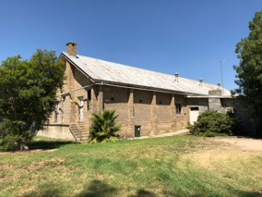
Image 1: Front Façade Image 2: Side and Rear Façade

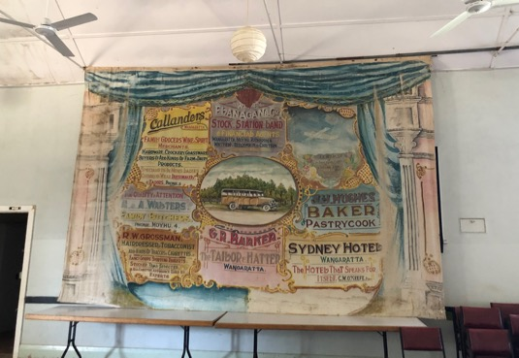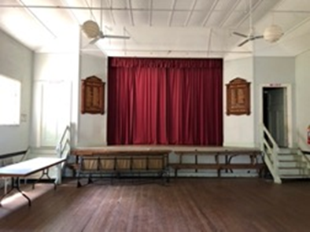
Image 3: Former backdrop cloth from the stage area Image 4: Stage flanked by Honour Rolls

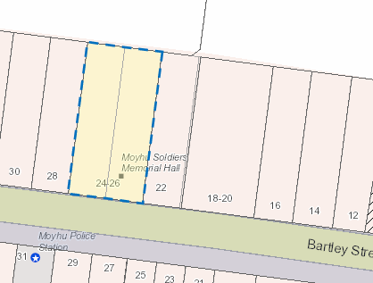
Location: 24-26 Bartley Street, Moyhu

What is significant?
24-26 Bartley Street (Soldiers Memorial Hall) is significant.
Significant fabric includes, but is not confined to:
- Original form, fabric and scale of the hall; all of the architectural features found at the hall including the: corrugated galvanised roofing; the conical capped vents; the gable roof; the concrete block chimney; the finish of the original concrete blockwork; the timber doors; the concrete blockwork buttresses; the original windows and the foundation stone to the front façade.
The context as provided by the setting which includes rear and side setbacks is significant.
The hall is substantially intact, and it has largely retained its original form.
The internal features which include the Honour Rolls; the stage area, original timber door and window joinery and the back-drop cloth and painted finish are significant. The integrity and intactness of the stage backdrop cloth is notable.
Elements which are not considered significant are:
- Alterations from the mid twentieth century and later are not significant. This includes the later skillion roofed addition to the side of the hall.
External paint and solar energy system controls apply. Internal alteration controls apply to the layout of the stage area, the Honour Rolls and to the cloth back drop.
How is it significant?
The Soldier’s Memorial Hall at 24-26 Bartley Street Moyhu is of local historical, rarity value, aesthetic, technical and social significance to Rural City of Wangaratta.
Why is it significant?
The Soldier’s Memorial Hall at 24-26 Bartley Street Moyhu is significant as it provides evidence of the settlement and establishment of the Moyhu township during the 1920s (Criterion A).

The Soldier’s Memorial Hall at 24-26 Bartley Street Moyhu is historically significant as it provides evidence of the impact of the Closer Settlement and Soldier Settlement policies that were implemented during the early twentieth century and the subsequent increase in population. These policies were aimed at increasing the number of settlers in rural areas. Many of the early settlers contributed to the development of a dairy industry and as it became more established through the construction of creameries and butter factories the economic conditions associated with smaller farming properties improved and this encouraged further rural growth. The raising of the funds and the building of the Hall as a Soldier’s Memorial provides evidence of the growth and establishment of the community at Moyhu. (Criterion A)

The painted cloth backdrop found in the Soldier's Memorial Hall is a rare surviving feature from the early twentieth century. The condition and intactness of this backdrop contributes to its rarity values. The cloth has advertising from local businesses as well as a memorial to a local young man (Criterion B)

The Soldier’s Memorial Hall at 24-26 Bartley Street Moyhu is of aesthetic significance for its simple utilitarian architectural expression. The austere presentation is accentuated by the plain finish and soft colour of the concrete block work. The dignity associated with the restrained architectural language speaks to it being constructed as a memorial to those who fought in World War I. (Criterion E)

The Soldier’s Memorial Hall at 24-26 Bartley Street Moyhu is of technical significance for its use of Depression era mechanical technologies in its construction. The use of mechanical block pressing machines were promoted as a cheap and easy means for those without building skills to create a building material. (Criterion F)

Primary source
Wangaratta Heritage Study, C & MJ Doring Pty Ltd and Michele Summerton, May 2004

Citation for 24-26 Bartley Street, Moyhu (Soldiers Memorial Hall), Heritage Concepts and Dr. Jacqui Durrant, June 2024

This document is an incorporated document in the Wangaratta Planning Scheme pursuant to section 6(2)(j) of the Planning and Environment Act 1987

