Wangaratta Planning Scheme

Moyhu-Meadow Creek Road, Moyhu (Former Lock Up, Lions Park) Statement of Significance

Heritage Place: | Moyhu-Meadow Creek Road, Moyhu (Former Police Lock Up, Lions Park) | PS ref no: | HO320

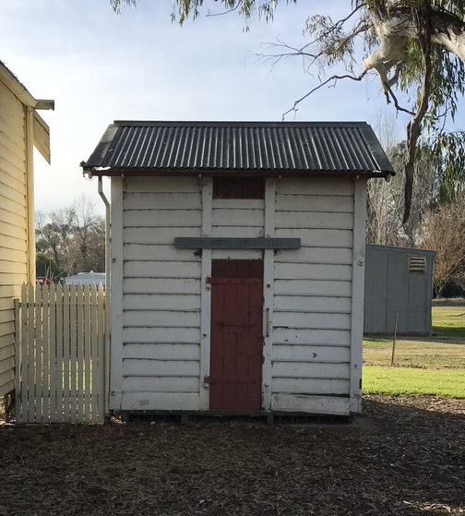
Image: Former Police Lock Up in Lions Park

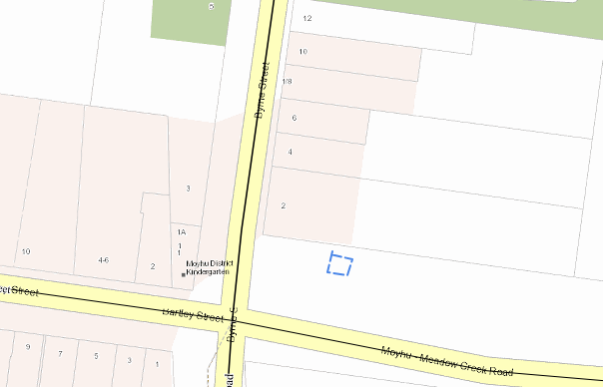
Location: Moyhu Meadow-Creek Road Lions Park (approx. location)

What is significant?
The Casterton model police lock up located within the Moyhu Lion’s Park, Corner of Moyhu Meadow Creek Road and Byrne Street Moyhu is significant.
Significant fabric includes, but is not confined to:
- The structure of the lock up and this includes the iron frame, external timber boarding and external iron banding · the metal framework with long square headed bolts through the walls, floor and ceiling
- The internal timber lining boards
- The vents with mesh cover and the exposed iron bars
- The solid timber and studded door with its brass lock, and
- The shallow pitched gable roof clad with corrugated metal
Elements which are not considered significant are:
- The other structures located within Moyhu Lions Park are not associated with the Police Lock Up and are not significant.
External paint and solar energy system controls apply. Internal alteration controls apply. The internal lining boards to the floor, ceiling and walls are integral to its significance and design as a secure lock up.
How is it significant?
The Casterton model police lock up is of local historical, rarity value, representative significance and technical significance to Rural City of Wangaratta.

Why is it significant?
The Casterton model police lock up is historically significant as it provides evidence of law and order in Moyhu.
The Casterton model police lock up is of historical significance as provides evidence of a police presence in the township from the late nineteenth century and into the twentieth century. The Casterton model police lock up is of historical significance as it provides evidence of the type of lock up that was used in Moyhu. The Casterton models were sent to the smaller regional centres from the late nineteenth century and up to the 1930s. (Criterion A)
The Casterton model police lock up is rare surviving building type in the Rural City of Wangaratta. (Criterion B)
The Casterton model police lock up is significant as a largely intact early twentieth century prefabricated lockup. Features of the lock up which express the typical characteristics of its class include its: structural system which includes its external timber cladding and external metal fixings; the shallow pitched gable roof clad with corrugated metal; the small rectangular vents found on each elevation; the external door constructed from cast iron, solid timber sections; iron bracing and iron hardware. The Casterton model police lock up is technically significant for its structural design and the materials that were used in its construction (Criterion D)
The Casterton model police lock up is technically significant for its structural design and the materials that were used in its construction. (Criterion F)

Primary source
Wangaratta Heritage Study, C & MJ Doring Pty Ltd and Michele Summerton, May 2004

Citation for Moyhu-Meadow Creek Road, Moyhu (Former Police Lock Up), Heritage Concepts and Dr. Jacqui Durrant, June 2024

This document is an incorporated document in the Wangaratta Planning Scheme pursuant to section 6(2)(j) of the Planning and Environment Act 1987

