

**Tourism Events Funding Program**

**Guidelines**

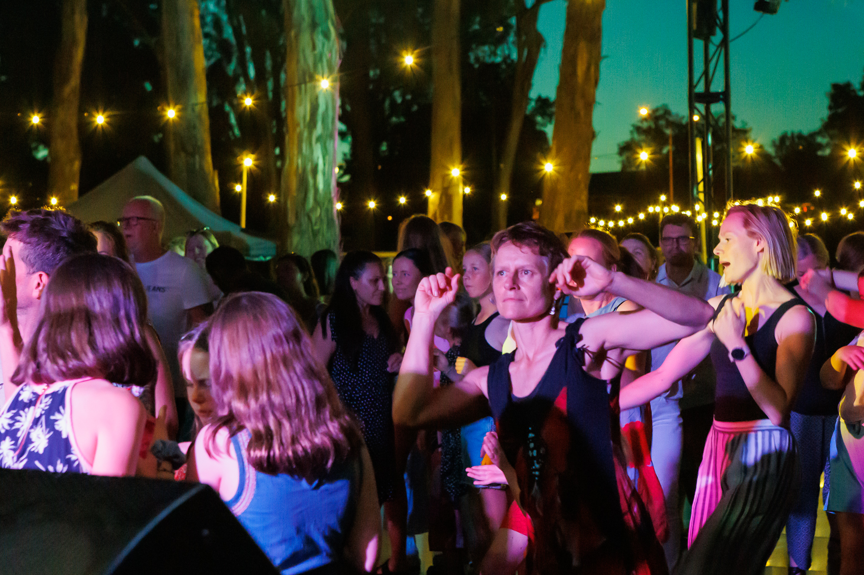

**wangaratta.vic.gov.au**



Contents­

About the Tourism Event Funding Program 4

Funding Streams Available 5

What can the funding be used for? 6

What expenses will not be funded? 6

When is the Tourism Event Funding Program open? 6

Tourism Event Grant 7

Tourism Event Sponsorship 12

What we won’t fund 17

Application Process 18

Frequently Asked Questions 21

Relevant Strategies and Policies 22

Acknowledgement of Traditional Owners

Rural City of Wangaratta recognises the rich Aboriginal heritage within the municipality and acknowledges the Traditional Custodians of this land. Council embraces Aboriginal and Torres Strait Islander living cultures as a vital part of Australia’s identity and recognises, celebrates and pays respect to the existing family members and to Elders past, present and future.

Thank you for your interest in the Tourism Event Funding Program

If you’re ready to apply for a grant, go straight to [**wangaratta.smartygrants.com.au**](http://www.wangaratta.smartygrants.com.au)

Otherwise, please read our guidelines to help you prepare your application.

Questions and Support

If you have any questions or would like to know about submitting your application, contact the friendly team at the Economic Development and Tourism department of the Rural City of Wangaratta.

**Phone**

03 5722 0888

**Email** economicdevelopment@wangaratta.vic.gov.au

# About the Tourism Event Funding Program

The Tourism Event Funding Program provides support for event organisers in assistance with developing and delivering vibrant, inclusive and engaging events in the Rural City of Wangaratta.

This program supports the growth of events in the region that attract outside visitation, have a strong tourism focus and demonstrates the potential to promote the Rural City of Wangaratta as a destination for visitors to our region all year round.

These events may be big or small, however they will share one thing: highlighting Wangaratta as a dynamic hub for tourism.

So, if you are planning an event or festival that that attracts visitors to the Rural City of Wangaratta and showcases the local area, then the Tourism Events Grant Program is designed to help you.

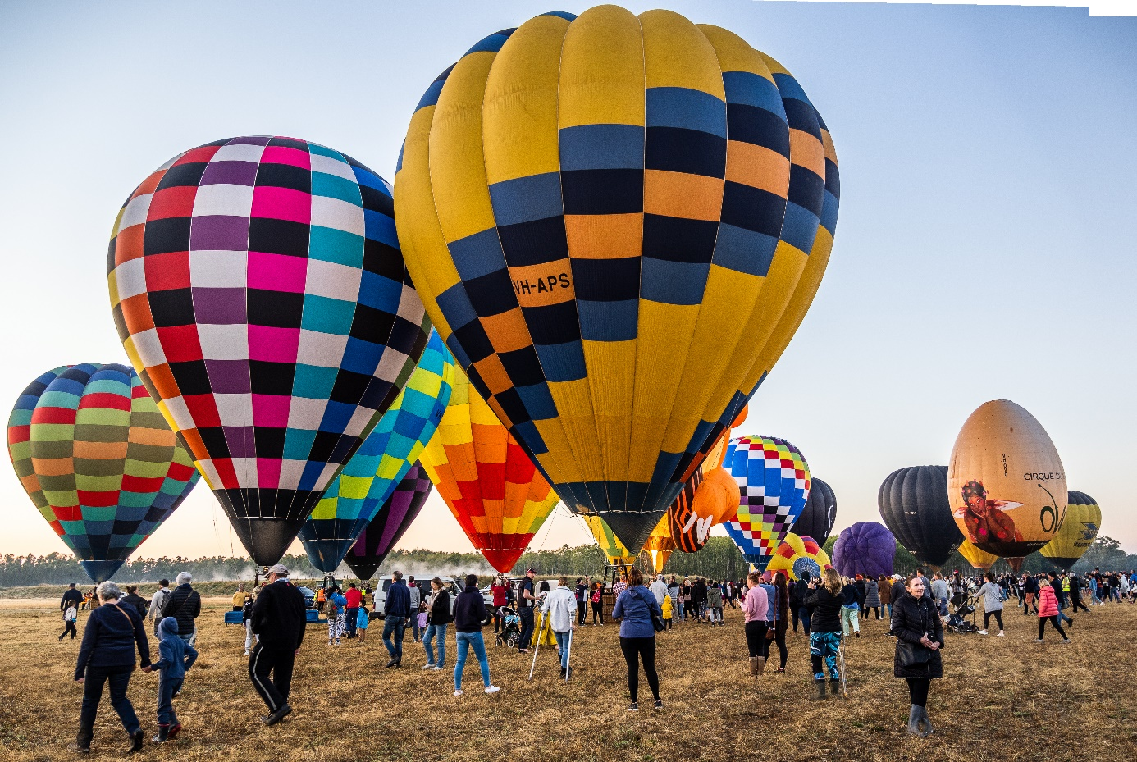

# Funding Streams Available

The Tourism Events Funding Program is split into two streams as below. This is a brief overview of the two streams, with further details about each stream further below.

1. Tourism Events Grants

Are you thinking of starting a new event in our region that will enhance Wangaratta as a holiday destination?   Or do you already host a tourism related event and would like to see it grow?   Then the annual Tourism Events Grants may be just the boost you need to get your idea off the ground allowing you to grow the event to become financially viable and sustainable in the future.

Focusing on helping new events to develop in our region or to grow events that have become all-time favourites, that also encourage overnight visitation and return visitation, this annual program provides funding of:

* Up to $5,000 for Marquee and Major events (greater than 500 visitors)
* Up to $2,000 for Minor events (less than 500 visitors

1. Tourism Event Sponsorship

Introduced in 2023, the Tourism Event Sponsorship aids prominent regional events which have already developed a strong following and have proved their economic benefit to the region as well as strong growth, thereby reallocating funds for emerging smaller events within the grants stream.  This program focuses on;

* Event growth rate
* Economic benefit to our community and overnight stays
* Regional significance and National profile
* Alignment with Tourism Pillars (Cycling | Food and Beverage | Nature | Arts and Culture)

Funding for the Sponsorship Program is up to $5,000 per year for a period of up to three-years.  A 'Memorandum of Understanding' will be established, reducing the need to re-apply each year.  This will free up time for event organisers to focus on growing their event into the future and allowing the grants team to assist new and upcoming event organisers to grow their event.

# What can the funding be used for?

* **Marketing, promotional materials & marketing activities** that increases the awareness of Wangaratta and appeals to visitors from outside our regional area.
* Costs associated with **securing and hosting events.**
* **Strategic or business plans** for event development.
* **New innovations** or additional activities to expand an event program.
* Other **innovate expenses** as specified in your application.

# What expenses will not be funded?

**The following expenses will not be funded under either stream.**

* **Prize money, awards** or activities associated with prizes or awards (e.g., trophies)
* **Alcohol licenses, tobacco and gambling** related activities.
* Requests for **fixed or permanent equipment, building maintenance or capital improvements** (e.g., heating or cooling systems, shade sails, solar panels, portable buildings, etc). This funding is specifically for the delivery of events within the Rural City of Wangaratta Municipality.
* Requests to fund **salaries, administration fees or personal expenses** (e.g., petrol, utility bills, phone bills that aren’t in the group’s name or aren’t incurred by the group).

# When is the Tourism Event Funding Program open?

**Applications Open**

Applications are open each September for the full month.

**Application Notifications**

Applicants will be notified of the outcome in early December.

# Tourism Event Grant

**Focusing on helping new events to develop in our region or to grow events that have become all-time favourites, this annual program provides funding of.**

* Up to $5,000 for Marquee and Major events (greater than 500 visitors)
* Up to $2,000 for Minor events (less than 500 visitors

**Marquee events**– attracts greater than 3,000 visitors & provides a significant economic benefit.

**Major events**– attracts between 500 to 2,999 visitors.

**Minor events**– attracts less than 500 visitors.

This grant **supports the growth and development** of events in the region that attract outside visitation resulting in economic benefits for the town.  Events supported under this program **must have a strong tourism focus** that demonstrate the potential to **promote the Rural City of Wangaratta as a destination** and aligns with the strategies of the Rural City of Wangaratta. This program has a strong focus on **supporting events in their early years**, enabling the event to become **financially sustainable and viable** in the future.

Applicants are required to outline how the funding will assist the event to contribute to one or more of the following key objectives:

* Attract visitors from outside of North East Victoria (overnight stays).
* Enhance Wangaratta as a holiday destination.
* Attract key target markets.
* Provides an economic benefit.
* Enhances the culture of the community.
* Supports and enhances the local tourism strengths.
* Grow the event to become financially viable and sustainable.

Who is eligible for a Tourism Event Grant?

* Community groups, organisations, businesses or for-profit organisations based in the Rural City of Wangaratta and holding event in the Municipality.
* Businesses or for-profit organisations based in the Rural City of Wangaratta.
* Events being held in the Rural City of Wangaratta.
* Businesses or for-profit organisations outside of the Rural City of Wangaratta but hosting their event in the Municipality of the Rural City of Wangaratta.

What events will the Tourism Event Grant fund?

Events supported under this program must have a strong tourism focus that demonstrate the potential to promote our municipality and aligns with the strategies of the Rural City of Wangaratta. This grant program has a strong focus on supporting events in their early years, enabling the event to become established, financially sustainable and viable into the future.

Successful applications under this stream must demonstrate that their event can.

* Increase visitation to the region from Intrastate and Interstate visitors.
* Enhance Wangaratta as a holiday destination.
* Support and enhances the local tourism strengths.
* Provides an economic benefit to our community and businesses.
* Enhances the culture of the community.
* Encourages overnight stays.
* Attract key target markets.
  + Overnight visitors
  + Visiting Friends and relatives
  + Lifestyle leader market
  + Nature and adventure
  + Food and wine lovers
  + Cultural and heritage tourists
  + Event specific visitors
* Sporting events that increase non-participant spectator attendance and tourism visitor appeal.

What won’t we fund?

* Local events with a community focus or appeal.
* Events without the capacity to attract visitation outside of the Rural City of Wangaratta.
* Events that have failed to acquit previous funding programs from the Rural City of Wangaratta or meet previous obligations from grant funding.
* Events that have already secured financial support through another Rural City of Wangaratta grant, program or source.
* Events that have already commenced at the time of application, or events that have been completed prior to the application.
* Events held outside of the Rural City of Wangaratta.
* 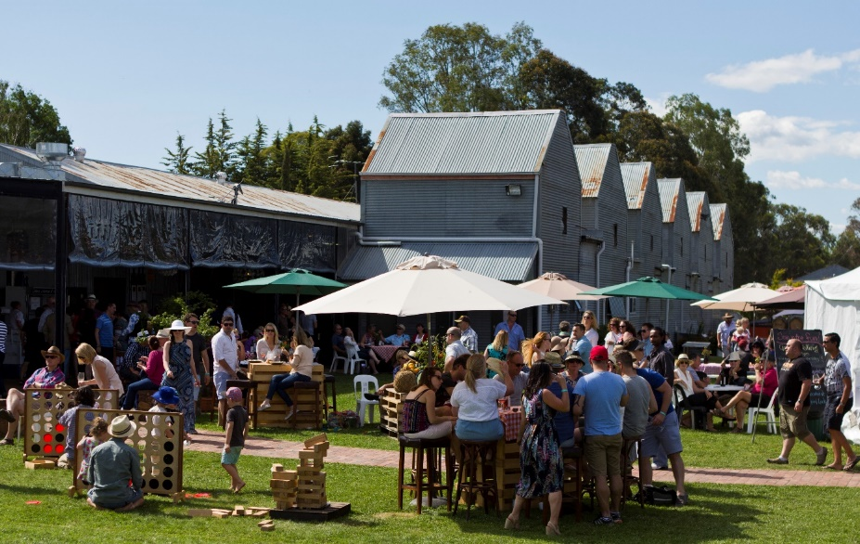Sporting events that are participant and support crew focused.

Tourism Event Grant Assessment Criteria

| Weighting | Criteria | Measure |
| --- | --- | --- |
| 20% | Event Longevity   * Has this event been held previously? * How many years has this event being held in the past? | * Events that are new or in their initial years will be given greater weighting. |
| 25% | Economic & Social Impact   * What is the economic or social impact to the community and businesses within the municipality? * How does this event align with the tourism strategies of the Rural City of Wangaratta, regional and state tourism? * Demonstrate the capacity to increase visitation from outside the Rural City of Wangaratta and immediate surrounding region. * Detail the events potential to develop into a key tourism or visitor attraction event. | * The extent to which the event or activity objectives and outcomes align with Council goals. * The extent of positive impact the event will have on residents both immediate and long term. * The extent of how the event will attract visitors and support local business. |
| 20% | Marketing & Promotion   * What is the target market of the event? * Provide a brief description of the marketing activities being undertaken to attract intrastate and interstate visitors to the event. * Is this an ongoing event? If so, what are you planning to do differently this year to drive further visitation and increased overnight stays? | * The extent of how the event will attract visitors and support local business. * How will the event capture visitor information. |
| 10% | Sustainability   * How sustainable is the event? * What are you implementing to ensure sustainability is a focus of the event? * How likely is it that the event will go ahead as planned? | * How well you address sustainability needs and opportunities. E.g., minimising waste, organics, and recycling, encouraging public transport or ride and walk, sustainable packaging use for stalls, ban on plastic straws and balloons. * Financial sustainability e.g., securing income and funding from other sources. * The extent of how well the event is planned and achievable, reasonable timeframe, previous experience, realistic event objectives, evaluation plan, knowledge of legislation, risk and safety, Child Safe standards. |
| 10% | Diversity & Equity   * How will you address the needs of people of different cultures and genders in the running and promotion of your event? * How will you measure gender reach of your event? | * The extent of positive impact the event has among the needs of different genders. * The capacity of and attraction of visitors from all backgrounds to attend this event or activity. e.g., Its openness to the public, free or low cost, ticket inclusions, attendance numbers, date, time, location, wheelchair accessibility, family friendly, interpreters, etc. |
| 15% | Budget   * Can you clearly show what costs and resources are needed to successfully execute the event or activity? * How well have you budgeted for the event or activity? * Are you able to demonstrate that your group is making a significant contribution to hosting the event? (In the form of cash, voluntary service or in-kind support). * What impact will there be on the event if you are not successful in getting a Council grant? | * Reasonable request, clear and realistic budget, inclusion of all items, supporting quotes, reliance on Council funding, benefits to Council. * How well you meet the requirements of funding based on the value requested. |

Tourism Event Grant Funding Agreement Criteria

The following items will form part of the Funding Agreement

* **Ensure the event has been held by December 31 2024** for the year the event was funded**.** I understand that I must notify Council if for any reason this cannot occur. In special cases, Council may consider extending the grant timelines.
* **Complete the participant survey** supplied by Rural City of Wangaratta or an agreed survey capturing a **minimum of 25% of participants**.
* Ensure the **Rural City of Wangaratta’s financial contribution/support is recognised** in any publicity, promotion or signage about the event. **Rural City of Wangaratta logo to be present on all digital and printed collateral, co-promote on social media.**
* **Invite a Councillor and/or senior representative** of the Rural City of Wangaratta to attend the event.
* Ensure the **grant is used for the event or activities nominated** in the application form or as per agreed with the Rural City of Wangaratta.
* Within 90 days of the conclusion of the event submit a **comprehensive acquittal report** on the outcome of the event together with receipts detailing expenditure of the grant and marketing material.
* **Return any unspent funds** to the Council unless otherwise agreed.
* **Accept all management and financial responsibility** for undertaking the project and any associated insurance costs or ongoing maintenance. Public Liability, Workcover or volunteer insurance as required must be valid at the time of the event.
* Agrees to **indemnify and to keep indemnified the Rural City of Wangaratta**, its servants and agents, and each of them from and against all actions, costs, claims, charges, expenses, penalties, demands and damages whatsoever which may be brought or made or claimed against them, or any of them, in consequence or connection with the event.
* **Invoice Council** for 50% prior to the event and 50% post event after approval of acquittal report.

# Tourism Event Sponsorship

Introduced in 2023, the Tourism Event Sponsorship aids prominent regional events that have demonstrated their sustainability and growth over time. The Sponsorship Program aims to simplify the procedure for event organizers, offering sponsorship for up to three years with annual reviews.

The Tourism Event Sponsorship Program focuses on events that demonstrate.

* Strong event growth rate
* Economic benefit to our community
* Regional significance and National profile
* Alignment with Tourism Pillars (Cycling | Food and Beverage | Nature | Arts and Culture)
* Sustainability and Cultural Wellbeing

Funding for the Sponsorship Program is **up to $5,000 per year for a period of up to three-years**, the funding value is determined by the above criteria.

A 'Memorandum of Understanding' will be established, reducing the need to re-apply each year.  This will free up time for event organisers to focus on growing their event into the future and allowing the grants team to assist new and upcoming event organisers to grow their event.  An acquittal report is required after each event, and the sponsorship reviewed annually.

What events will the Tourism Event Sponsorship fund?

Events supported under this program have a **strong tourism focus** that demonstrate the potential to **promote Wangaratta and surrounds** as an ideal **tourism destination** and aligns with the strategies of the Rural City of Wangaratta. The Tourism Sponsorship Program is aimed at those tourism events that have **demonstrated a strong success rate and steady growth** over the past years.

Successful applications under this stream will demonstrate that their event can.

* Continue to grow or establish innovate activities as part of the event.
* Provide an economic benefit to our community and businesses.
* Attract visitors to the region and enhance Wangaratta as a holiday destination.
* Increase overnight visitation.
* Develop the event to hold regional or national significance.
* Support and enhances the local tourism strengths.
  + Cycling
  + Food & Beverages
  + Nature
  + Arts & Culture
* Attract key target markets.
  + Overnight visitors
  + Visiting Friends and relatives
  + Lifestyle leader market
  + Nature and adventure.
  + Food and wine lovers
  + Cultural and heritage tourists
* Sporting events that increase non-participant spectator attendance and tourism visitor appeal.

What won’t we fund?

* Local events with a community focus or appeal.
* Events without the capacity to attract visitation outside of the Rural City of Wangaratta.
* Events that have failed to acquit previous funding programs from the Rural City of Wangaratta or meet previous obligations from grant funding.
* Events that have already secured financial support through another Rural City of Wangaratta grant, program or source.
* Events that have already commenced at the time of application, or events that have been completed prior to the application.
* Events held outside of the Rural City of Wangaratta.
* New events (new events are encouraged to apply for funding through the Tourism Event Grant stream of this program).
* Sporting events that are participant and support crew focused.

Who is eligible for Tourism Event Sponsorship?

* Community groups or organisations based in the Rural City of Wangaratta.
* Businesses or for-profit organisations based in the Rural City of Wangaratta
* Events being held in the Rural City of Wangaratta.
* Events that have been held previously in our region.

Tourism Event Sponsorship Assessment Criteria

| Weighting | Criteria | Measure |
| --- | --- | --- |
| 10% | Event Longevity   * How many days will this event be held? * How many years has this event being held in the past? | * Greater weighting will be placed on events that span across multiple days. |
| 25% | Economic & Social Impact   * What is the economic or social impact to the community and businesses within the municipality? * How does this event align with the tourism strategies of the Rural City of Wangaratta, regional and state tourism? * Demonstrate the capacity to increase visitation from outside the Rural City of Wangaratta and immediate surrounding region. * Detail the events potential to develop into a key tourism or visitor attraction event. * What is the rate of growth of this event over the last three-year period? | * The extent to which the event or activity objectives and outcomes align with Council goals. * The extent of positive impact the event will have on residents both immediate and long term. * The extent of how the event will attract visitors and support local business. |
| 20% | Marketing & Promotion   * What is the target market of the event? * Brief description of the marketing activities being undertaken to attract intrastate and interstate visitors. * Is this an ongoing event? If so, what are you planning to do differently this year to drive further visitation and increased overnight stays? * Will you be developing packages with local accommodation, tour and transport operators for your event? | * The extent of how the event will attract visitors and support local business. * How information will be captured. |
| 10% | Sustainability   * How sustainable is the event? * What are you implementing to ensure sustainability is a focus of the event? * How likely is it that the event will go ahead as planned? | * How well you address sustainability needs and opportunities. E.g., minimising waste, organics, and recycling, encouraging public transport or ride and walk, sustainable packaging use for stalls, ban on plastic straws and balloons. * Financial sustainability e.g., securing income and funding from other sources. * The extent of how well the event is planned and achievable, reasonable timeframe, previous experience, realistic event objectives, evaluation plan, knowledge of legislation, risk and safety, Child Safe standards. |
| 10% | Diversity & Equity   * How will you address the needs of people of different cultures and genders in the running and promotion of your event? * How will you measure gender reach of your event? | * The extent of positive impact the event has among the needs of different genders. * The capacity of and attraction of visitors from all backgrounds to attend this event or activity. e.g., Its openness to the public, free or low cost, ticket inclusions, attendance numbers, date, time, location, wheelchair accessibility, family friendly, interpreters, etc. |
| 25% | Budget   * Clearly indicate the costs and resources are needed to successfully execute the event. * How well have you budgeted for the event? * Demonstrate that your group is making a significant contribution to hosting the event? * What impact will there be on the event if you are not successful in getting a Council grant? | * Reasonable request, clear and realistic budget, inclusion of all items, supporting quotes, reliance on Council funding, benefits to Council. * How well you meet the requirements of funding based on the value requested. |

Tourism Event Sponsorship Funding Agreement Criteria

The following items will form part of the Funding Agreement

* **Ensure the event has been held by December 31** for the year the event was funded**.** Council must be notified if for any reason this cannot occur. In special cases, Council may consider extending the grant timelines.
* **Complete the participant survey** supplied by Rural City of Wangaratta or an agreed survey capturing a **minimum of 25% of participants**.
* Ensure the **Rural City of Wangaratta’s financial contribution/Support is recognised** in any publicity, promotion or signage about the event. **Rural City of Wangaratta logo to be present on all digital and printed collateral, co-promote on social media.**
* **Invite a Councillor and/or senior representative** of the Rural City of Wangaratta to attend the event.
* Ensure the **grant is used for the event or activities nominated** in the application form or as per agreed with the Rural City of Wangaratta.
* Within 90 days of the conclusion of the event submit a **comprehensive acquittal report** on the outcome of the event together with receipts detailing expenditure of the grant and marketing material.
* This sponsorship is subject to an **annual review** and may be ceased in the case of the event not occurring, being moved to a location outside of the Rural City of Wangaratta, not meeting funding conditions, non-submission of yearly acquittal report and other factors as seen to be grounds for termination by council officers.
* **Return any unspent funds** to the Council unless otherwise agreed.
* **Accept all management and financial responsibility** for undertaking the project and any associated insurance costs or ongoing maintenance. Public Liability, Workcover or volunteer insurance as required must be valid at the time of the event.
* Agrees to **indemnify and to keep indemnified the Wangaratta Rural City of Wangaratta**, its servants and agents, and each of them from and against all actions, costs, claims, charges, expenses, penalties, demands and damages whatsoever which may be brought or made or claimed against them, or any of them, in consequence or connection with the event.
* **Invoice Council** for 50% prior to the event and 50% post event after approval of acquittal report.

# What we won’t fund

**The following events will not be funded under either stream.**

* Local events with a community focus or appeal.
* Events without the capacity to attract visitation outside of the Rural City of Wangaratta.
* Events that have failed to acquit previous funding programs from the Rural City of Wangaratta or meet previous obligations from grant funding.
* Events that have already secured financial support through another Rural City of Wangaratta grant, program or source.
* Events that have already commenced at the time of application, or events that have been completed prior to the application.
* Political organisations, or events that have a political purpose.
* Events that exclude or may offend parts of the community.
* Applications that don’t meet eligibility requirements including:
  + Proposals to host events or activities that are not located within the Rural City of Wangaratta LGA.
* Applicants who have:
  + Outstanding debts with Council.
  + Outstanding acquittals from previous funding.
* Applications that do not adhere to program guidelines including:
  + Incomplete or incorrect applications, including applications that are missing supporting documents.
  + Proposals that do not align with Council’s values of trust, respect, excellence, enjoyment fairness and openness.
* Applications that include illegal activity or a proposed event that may negatively impact the community or natural environment.
  + Events that may compromise Council’s reputation, image, probity or ability to fulfil its functions and responsibilities.
* Events that don’t have public liability insurance. Evidence of Public Liability Insurance will be required prior to funding being made available.
* Sporting events that are participant and support crew focussed.

Council retains the right to decline a Grant agreement with any external party, in respect to particular products or services for which Council, in its sole discretion, considers inappropriate, inopportune or if costs and inputs outweigh the benefits.

# Application Process

Before making an application

To help plan for your application, you should prepare the following information before starting the application form on SmartyGrants:

1. Confirm that you are **eligible** (see eligibility).
2. Confirm that your event or activity **is in line with** [**Council’s goals**](https://www.wangaratta.vic.gov.au/files/assets/public/council-plan-2021-2025.pdf) .
3. Gather information about your organisation, group, or business (bank details, ABN)
4. **Detail your planning** for your event:
   * An **overview of the event** or activity (including dates, times, and locations).
   * The **objectives** (or the desired outcomes) of the event and activity.
   * How the event or activity is in line with the tourism pillars of the Rural City of Wangaratta.
   * How the event organiser will deliver an **environmentally and financially sustainable event**.
   * Identify other **existing or potential funding sources**.
   * Identify how the event will address **cultural and gender diversity** and equality.
5. **Prepare your application**.
   * Estimate your event **attendance**.
   * Consider what **grant stream** you will be requesting.
   * A **proposal on how Council’s Grant will support the event** or activity including quotes for components the Grant intends to cover.

* **Prepare a detailed event budget.**
* How the **event fits within the grant criteria** linking to Council goals and strategies.
* Prepare the following documentation that may need to be included in your application:
  + Current Certificate of Public Liability Insurance
  + Marketing Plan
  + Emergency Management Plan
  + Site Plan

If your application is successful

* You will be informed of the outcome of your grant request in writing.
* You will receive a Letter of Offer with a Funding Agreement document.
* The Funding Agreement document sets out the terms on which Council is prepared to make the grant available.
* You must enter into an agreement with Council before any money can be paid.
* To accept the grant offer, you must complete, sign, and return the Funding Agreement document to Council, accepting the terms and conditions.
* Grant monies will be paid by Electronic Funds Transfer in two payments. The first 50% will be paid after the return of the signed Funding Agreement and the final 50% will be paid upon the grant acquittal being returned and accepted.
* You must spend the money for the purpose outlined in your application and agreement.
  + If your plans change (timing, budget, or project), you need to submit a variation request to Council, and have it approved, before you make any changes to your project.
  + If you spend the funding differently than your application or funding agreement without approval, Council will ask for all grant monies to be returned.
* As part of the terms of the Funding Agreement, you are required to submit an Acquittal or accountability Report that shows how the grant money was used. You will also need to show proof that money was spent (e.g., receipts or financial reports).
* If any element of the event costs less than you expect, or doesn’t occur, you are required to return any unspent funds to Council. You are required to do this unless you have been granted prior written consent by Council.

If your funding is unsuccessful

If you application is unsuccessful, you can request feedback by emailing **economicdevelopment@wangaratta.vic.gov.au**

A member of the Economic Development and Tourism Team will respond to your enquiry and provide general advice regarding your application, including whether it was invalid due to inadequate information, or not aligning with Council values. Council is not able to discuss the outcome of any other applications with you.

Given this process is competitive and often receives a large volume of applications, there is no review or appeals process. If you have any concerns about the handling of your application, you can submit an enquiry to [**economicdevelopment@wangaratta.vic.gov.au**](mailto:economicdevelopment@wangaratta.vic.gov.au)



**Important Information**

* The decision to award grants is made by Rural City of Wangaratta Council.
* Rural City of Wangaratta’s Tourism Event Funding Program is a competitive process and funds are awarded based on merit.
* The Tourism Event Funding Program is in line with the [Grants and Sponsorship Policy](https://www.wangaratta.vic.gov.au/files/assets/public/files/policies-amp-documents/your-council/policies/grants-and-sponsorships-policy-2022.pdf).
* Council reserves the right to offer a reduced value grant and as such, assess against the relevant revised value requirements.
* Council’s decision is final. There is no review or appeal process.
* Canvassing of Councillors and Officers, or any attempts to influence the outcome of the grant application or process, is prohibited and will render an application ineligible.
* All events or activities held on Council Owned Spaces must comply with the Event Terms and Conditions. This includes obtaining relevant permits, completing relevant application forms, and providing relevant event management plans. More information can be found on the Rural City of Wangaratta website- [Planning an event](https://www.wangaratta.vic.gov.au/Business/Planning-an-event).
* All events or activities held on private land must comply with relevant requirements. A Planning permit may be required, in which case it must be obtained and complied with.
* More information about registrations and permits including Itinerant Trading Permits can be found on the [Registration and Permits](https://www.wangaratta.vic.gov.au/Business/Registrations-and-permits) section of the Rural City of Wangaratta website.
* If a successful applicant fails to meet these conditions at the time of the event, they may be required to pay back monies paid by Council.
* If a successful applicant fails to meet these conditions at any time before, during or after the event, they may be required to pay back monies paid by Council.
* Council reserves the right to withdraw support or ask for funds to be returned if you do not comply with Council policy or any written agreement entered into.

# Frequently Asked Questions

**What if you have sponsored my event in the past?**

There is no limit to the number of times that you can apply or receive grants, however events that have been funded numerous times may be advised to apply under the Sponsorship stream.

**Who makes the final decision?**

Councillors will make the final decision at a Council meeting, in line with its [Grants and Sponsorship Policy](https://www.wangaratta.vic.gov.au/files/assets/public/files/policies-amp-documents/your-council/policies/grants-and-sponsorships-policy-2022.pdf).

**Can I apply for another grant, if I haven’t provided a final report and acquitted the last grant or sponsorship?**

No. If you have not evidenced how your previous grant was spent (provided an acquittal), your application will be assessed as ineligible.

**How will I know if my application has been successful?**

A letter will be sent to you advising of your application outcome. This will be sent to the email address indicated on your application form.

**How are payments made?**

When you receive the letter stating that your application was successful, you will be asked to provide an invoice for the amount that you have been funded. You will receive the first 50% of funding upon receipt of the funding agreement and receiving an invoice. The final 50% will be paid upon completion and endorsement of your acquittal report after the event.

**Can I get feedback if my application is not successful?**

Yes, you can email economicdevelopment@wangaratta.vic.gov.au to ask for feedback.

**What happens if my event can’t proceed as proposed?**

If your event cannot proceed, you will need to contact Council immediately to discuss.

**Do I need to complete an acquittal?**

Yes. Successful applicants will be required to submit an acquittal after the event detailing the return on investment to Council, as well as proof of spending of the grant funds for the event.

**Can I apply for multiple funding?**

No. You can only apply for one round of funding for the financial year.

# Relevant Strategies and Policies

**Where can I find the relevant strategies referred to in these guidelines?**

[Economic Development and Tourism Strategy](https://www.wangaratta.vic.gov.au/files/assets/public/files/policies-amp-documents/your-council/strategies-and-plans/economic-development-and-tourism-strategy-2018-2023.pdf)

Tourism Northeast Destination Management Plan and Strategies

[Grants and Sponsorship Policy](https://www.wangaratta.vic.gov.au/files/assets/public/files/policies-amp-documents/your-council/policies/grants-and-sponsorships-policy-2022.pdf)

[Council Plan 2021-2025](https://www.wangaratta.vic.gov.au/files/assets/public/council-plan-2021-2025.pdf)

